Zebra Mussels
Bruce Carlson

As I’m sure almost all of you know by now, this past October the DNR reported that zebra mussel larvae have been found in Ten Mile. Given all of our efforts to prevent the introduction of invasive species into the lake, it was disappointing to learn that, at least for zebra mussels, these efforts failed. I was asked to write an article about zebra mussels for the Newsletter. This article will be organized into four sections – 1) some general information about zebra mussels; 2) a brief history of their spread; 3) their effects on a lake; and 4) what their possible impact on Ten Mile might be.

A Bit about Zebra Mussels

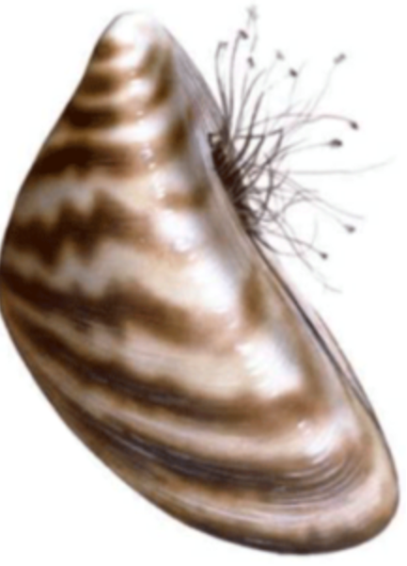
Zebra mussels (Dreissena polymorpha) are molluscs, just like the freshwater clams that we have in Ten Mile, but there are also some big differences. An adult zebra mussel doesn’t grow much larger than 1-2” in length, and their reproductive habits differ quite a bit from our clams. Zebra mussels get their name from the stripe pattern on their shells (Fig. 1). A close relative of theirs, called a quagga mussel also has stripes, but they fade out toward the edges of the shell. I’m bringing up quagga mussels, another invasive, because when they and zebra mussels are found in the same water, the quagga mussels often squeeze out the zebra mussels and completely take over because they can survive at greater depths. This is what has happened in Lake Michigan. So much for quagga mussels for this article.

Adult zebra mussels adhere to hard objects, like rocks and wood, and do so by means of what are called byssal threads, the stringlike projections that you can see coming from the shell in figure 1. Byssal threads are remarkable. They are stronger than steel, but also have elastic properties. These properties, plus their stickiness, allow mussels to adhere to hard objects even in the face of pounding waves (as is the case for ocean mussels). In fact, only recently have bioengineers started investigating their biological and mechanical properties for industrial applications (think of Velcro and its conceptual origin by a man who wondered why thistles stick so tightly to your clothes).

Zebra mussels are filter feeders. Through a siphon system, the details of which I won’t bore you with, a single adult zebra mussel passes about a quart of water through its body per day and filters tiny plankton organisms from the water. Most of what they filter out and consume is phytoplankton, microscopic algae that form the base of the aquatic food pyramid. This is of great significance to the overall ecology of a lake because it affects almost all of the animal life in the lake. Filtered material that they can’t use for food becomes covered with mucus and is deposited on the lake bottom as what is called pseudofeces. In some lakes, the pseudofeces concentrate contaminants in the water. More on the effects of their feeding habits on a lake later.

Zebra mussels lay eggs which, unusually for many molluscs, are fertilized in the water. A single female produces 30,000 – 40,000 eggs per cycle and up to a million eggs per year. Three to five days after the eggs are fertilized, they develop into larval forms called veligers, which passively float in the water. A veliger is almost microscopic, being .002 - .003 inches in length. At this stage, the veligers are at the mercy of water currents, which determine how they become distributed. (As an aside, almost every lake has currents, most of which are not noticeable to the casual observer.) After 2-3 weeks, the veligers begin to develop fragile shells based on calcium (Ca⁺⁺) found in the lake water. The water must contain 10 parts per million (ppm) of Ca⁺⁺ to initiate and 25 ppm to maintain shell growth. As they begin to form their shells, they begin to drop to the bottom of the lake and look for a suitable substrate upon which to settle. At this stage they do have limited mobility. Once they find a substrate that they like, they begin to produce byssal threads, by which they attach to that substrate, often a rock. The attached baby mussels then begin feeding and grow. Ideal water temperatures for zebra mussel growth are between 68 and 77 degrees. Within 6-7 weeks after settling down, a zebra mussel begins to reproduce, and the life cycle repeats itself. Most zebra mussels probably don’t live more than 2-3 years, but in Europe, they are known to live up to five years.

The Spread of Zebra Mussels

Zebra mussels are native to the lakes and rivers in the area of the Black and Caspian Seas. As early as the mid-1800s, they had already spread into many central European countries and Sweden, as well. In North America, they were first detected in Lake St. Clair, near Detroit, in 1988, and it is thought that they were brought over by a freight ship that came from the Black Sea. They could have entered our waters as veligers from emptied ballast water or from adults that were stuck to anchor chains. Whatever the case, they rapidly spread so that by 1994, they were found in most major river systems in the central and eastern parts of the USA. Commercial barges were probably the main contributor to their spread in this early phase. Since then zebra mussels have spread to many of our eastern and midwestern lakes (Fig. 2). They are continuing to spread at a steady rate, mainly because of contamination by veligers from boats or minnow buckets, or by live adults attached to docks or boat lifts coming from an infested lake to a non-infested one.

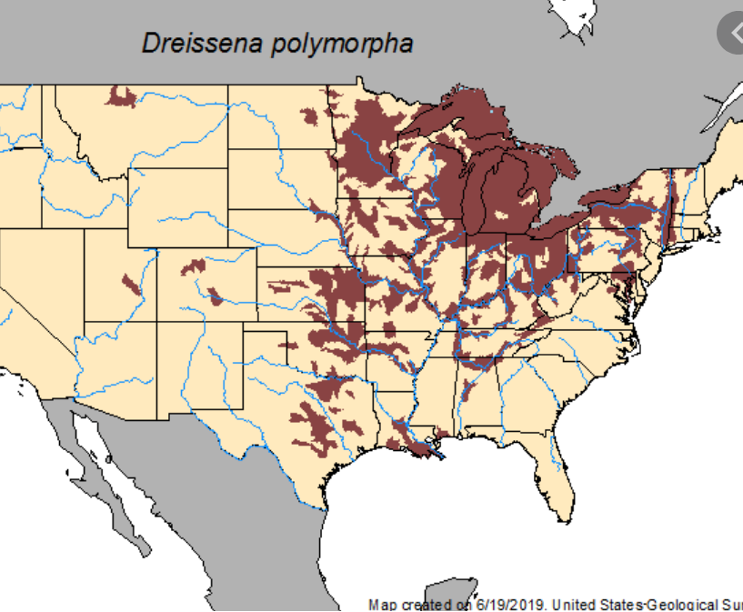
In Minnesota, zebra mussels were first found in the Duluth harbor of Lake Superior in 1988, but because of the nature of the water in that lake, their impact has been minimal. They were first detected in the Mississippi River south of Minneapolis and the St. Croix River in 1992. Since then, they have been spreading into almost all of our major lakes.

Within a lake, the first indication of zebra mussels is usually the presence of veligers in the water. If there are enough to be detected in plankton samples, then there is probably already a reproducing population of them somewhere in the lake. This is the stage of their spread presently in Ten Mile. At first, the ramping-up process of the population seems very slow, but at some point it explodes. As an example, in Lake Winnibigoshish adult mussels were not found until four years after veligers were detected in the water, but two years later, adults were found everywhere.

In most ecological systems, when an invasive is introduced, it undergoes a population explosion shortly after initial establishment, and then the number declines somewhat. In Lake Mille Lacs, where zebra mussels were first found in 2005, their density in 2013 dropped from 1,270/ft² to 1,070/ft². Nevertheless, it is estimated that at present there are about two trillion zebra mussels in that lake.

What Are the Effects of Zebra Mussels in a Lake?

All lakes aren’t affected in the same way by zebra mussels. Their impact depends upon many characteristics of the lake. Zebra mussels prefer hard substrates, so lakes with rocky bottoms are ideal for them. They also need sufficient calcium in the water in order to form shells. The very infertile water of Lake Superior is a major factor that limits their spread in that lake. Another factor is temperature. As mentioned above, their ideal temperature is 68-77 degrees. This is another factor that limits their spread in Lake Superior, which is much colder. Ideal depths for zebra mussels are between 6 and 45 feet, but they have been found as deep as 100 feet in some lakes.

One of the most noticeable effects of zebra mussels on a lake is an increase in water clarity. This is due to the filtering out of much of the phytoplankton, which is a major factor that limits water clarity. The increase in water clarity itself can have a major impact on a lake. Increased clarity allows greater penetration of sunlight in the water, and that allows aquatic plants to grow at a greater depth (Check my “Beneath the Surface” book, pp. 19-23 for a more detailed treatment of light effects). It can also greatly affect the behavior of fish and other animals. Those that are sensitive to light will seek deeper water. This can affect fishing because there may be more activity at night.

Of critical importance to a lake is the effect of zebra mussels on the food chain (see “Beneath the Surface”, pp. 34-35). Zebra mussels filter out much of the phytoplankton from the water of a typical lake. They also remove some of the smaller zooplankton – the next layer above in the food chain. Zooplankton feed upon phytoplankton, so the remaining zooplankton may be starved of food. As an example of what can happen, Lake Carlos (another sentinel lake, like Ten Mile) has experienced a 2/3 drop in zooplankton density in the nine years since zebra mussels were first found in that lake. Small fish and some other invertebrates feed upon plankton, so if plankton levels drop, these animals lose their food source, resulting in reduced numbers or growth. This effect carries up the food chain, so that larger fish may not find sufficient numbers of smaller fish to eat in order to remain in top condition.

The presence of zebra mussels can cause the character of a lake to change. Lakes where the food chain is pelagic (open water-based) may transition to what is called a more benthic (bottom-based) food chain that is based upon the presence of huge numbers of zebra mussels on the bottom. Ten Mile tends toward a more pelagic base for the food chain. For a couple of specific examples, in Lake St. Clair, where zebra mussels were first found, the perch population increased five-fold. One reason is that the perch began feeding upon the pseudofeces produced by the zebra mussels. This is a case where there was a positive effect of the mussels upon one species. A number of lakes have found improvements in the smallmouth bass populations. There may be several direct or indirect reasons for this.
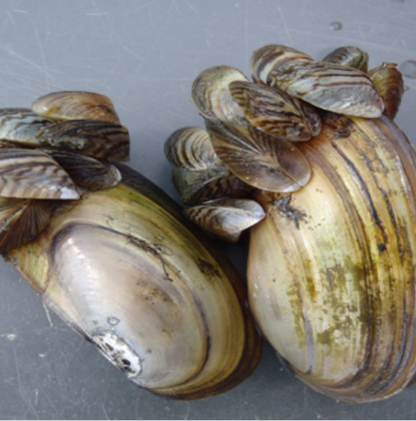
A major negative effect of zebra mussels is found on freshwater clams. Zebra mussels adhere to their shells, sometimes by the hundreds or even thousands per clam (Fig. 3). In some eastern lakes, the clam populations have been almost extinguished. With crayfish, it can be a mixed bag. An adult crayfish can eat up to 100 small zebra mussels per day, but on the other side of the coin, zebra mussels adhere to the hard carapace of the crayfish to the extent that they can become immobilized. Crayfish, however, have an advantage over clams in that as they grow, they periodically shed their carapace and grow a new larger one which, for the time being, is free of mussels.

What Are the Prospects for Ten Mile?

At this point, it is hard to make definitive projections for the effects of zebra mussels on Ten Mile in future years. It is likely that for a couple of years, at least, we won’t see much. At what point a real explosion of adults is seen can’t be determined exactly, but I suspect that within 3-5 years, adults will be found around most parts of the lake. For most residents, they will be most visible when attached to dock posts and boat lifts. By the way, don’t have any part of your boat remaining in the water when not in use or zebra mussels will cover the hull and especially the propeller and other submerged parts of the motor. Sandy parts of the lake will likely be less affected than area with rocky shorelines, but the clams in these areas are likely to become covered with mussels. In addition, sandy beaches are likely to see accumulations of shells of dead mussels. These are sharp and may necessitate wearing shoes while being in the water.

For those who fish walleyes, I think it’s safe to assume that within a few years the rocks that cover the underwater islands will be completely blanketed with zebra mussels. Their sharp shells could result in cut lines. Because the water in Ten Mile is already so clear, it’s hard to say how much clearer the water might get. My guess is not much, but even a little bit would put the walleyes down deeper during the day.

The most important thing to watch for in Ten Mile is the effect of zebra mussels on the dwarf cisco population. It is estimated that there are from 6-8 million ciscoes in the lake. These fish are plankton feeders, and if there is a major diminution in the zooplankton, it could have a significant effect on the cisco population. Interestingly though, Ten Mile Lake has a very low population density of zooplankton. For example, it is over ten times lower than that of Lake Itasca. The lower density of plankton could have a limiting influence upon the population of zebra mussels that Ten Mile could support. Another potential positive feature of Ten Mile is its great depth. Some parts of lake waters don’t mix much, and much of the water in Ten Mile is over 50 feet deep. It will be interesting to see if the plankton over the deep waters in the lake are somewhat protected from filtration by the zebra mussels. If so, this would benefit our cisco population.

If the cisco population does become depleted by the effects of zebra mussels on plankton, it is possible that their role in the food chain for game fish could be supplanted by an increase in the perch population if our perch begin feeding upon mussel pseudofeces like they are known to do in some lakes. This is a big unknown.

It is highly likely that our local clams will be adversely affected by zebra mussels. How badly is hard to predict. An unknown to me, at least, is how the populations of aquatic insect larvae (e.g. mayflies, caddis flies, midges, etc.) will be affected.

Another unknown is the possible effect of the physical properties of the lake in supporting or not supporting zebra mussels. In 2014, Cass County commissioned an important report outlining the potential susceptibility of its major lakes to both the likelihood of infestation by zebra mussels and, if infested, the likely severity of the infestation. Unfortunately, based upon physical characteristics, most Cass County lakes are considered to provide wonderful opportunities for zebra mussel expansion once they gain access to the lake. Ten Mile is no exception, and it is considered to be one that provides a good environment for zebra mussel establishment and growth.

There are, however, some potential mitigating factors that could work in the favor of Ten Mile. One is its great depth, which might protect many parts of the lake from mussel growth. Another is the large area of sandy bottom that covers much of the lake. Sand is not a good substrate for zebra mussel attachment. The low concentrations of plankton in Ten Mile may also have a significant limiting effect on the spread of zebra mussels. Unfortunately, the normal summer water temperatures in Ten Mile are in the ideal range for happy zebra mussels. In some lakes in Michigan there have been huge die-offs of zebra mussels when the water temperatures have reached the upper 80s for a number of days. (This might be one case of a positive effect of global warming!)

A final note about the spread of AIS both into and from Ten Mile Lake. Since Ten Mile is at the top of the Boy River watershed, all lakes downstream could be exposed to zebra mussel veliger-contaminated water emanating from Ten Mile. Birch Lake is the first downstream lake, and it is connected to Ten Mile by a roughly mile-long stretch of the Boy River. What are the prospects for Birch? Fortunately, the characteristics of that stretch of stream will be protective of Birch Lake. A number of studies have looked at downstream spread of zebra mussel veligers. For a typical stream, any lake less than 12 miles downstream is considered to be at great risk of contamination by veligers coming from an upstream contaminated lake. For highly vegetated, slow-moving streams, however, even a mile of separation may be sufficient for protection. The Boy River is in this latter category. Both its low flow and abundant aquatic vegetation may act as deterrents to rapid spread of veligers. Nevertheless, Birch lake should be closely monitored from now on.

Regarding Ten Mile, all of us should be very careful if we are to move boats from Ten Mile to any other body of water in order to reduce the likelihood of contamination coming from our lake. Also, we should continue to be vigilant about trying to prevent the introduction of other AIS into Ten Mile. Therefore, continued monitoring and common-sense care will remain important.

Looking into the Future

Fortunately, Ten Mile is one of 25 sentinel lakes in Minnesota. Sentinel lakes have been heavily studied since that program began, and as a result there is already a large database on many physical and biological characteristics of the lake. This, along with the unusual depth of the lake, makes Ten Mile an ideal lake in which to study the impact of a zebra mussel infestation from the very beginning, similar to the study already underway on Lake Carlos. By continuing to collect the types of data that are already being collected, we should have a very good record of the impact of zebra mussels on many aspects of the lake. At last summer’s TMLA annual meeting, I briefly reported on the initial stages of my underwater survey of the lake through documented videos. The timing of this was very fortunate, because we already have a pretty good picture of what the lake is like in the pre-zebra mussel stage. I plan to continue this in future years and will identify specific sites that are likely to have zebra mussel colonies in the future.

I have already had discussions with some folks in the DNR about how we can document the spread of zebra mussels in Ten Mile. One important method that could be used is to identify specific sites in the lake and do counts of mussels in defined areas. Much of this is best done through diving. If any Ten Mile residents would be interested in participating by doing scuba diving surveys of key areas, please contact me by e-mail (brcarl@umich.edu). Working with the DNR, we could set up an important component of the overall survey.

In summary, even though we have news that we didn’t want to get, I’m hoping to make at least some lemonade from the lemon that has been presented to us. How we deal with the zebra mussel problem in the future will likely involve many folks around the lake. I’m sure that this will be a major focus of the TMLA Board, so keep tuned for reports and requests for help.

